### **Step 1: Updating System and Installing mdadm for Managing RAID**

**1.** Before setting up RAID0 in Linux, let’s do a system update and then install ‘**mdadm**‘ package. The mdadm is a small program, which will allow us to configure and manage RAID devices in Linux.

# yum clean all && yum update

# yum install mdadm -y

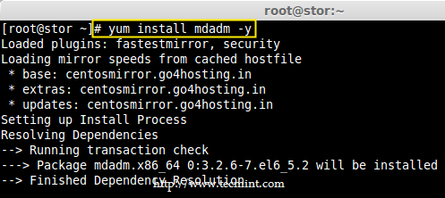

Install mdadm Tool

### **Step 2: Verify Attached Two 20GB Drives**

**2.** Before creating RAID 0, make sure to verify that the attached two hard drives are detected or not, using the following command.

# ls -l /dev | grep sd

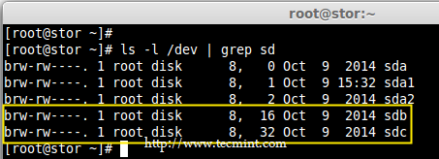

Check Hard Drives

**3.** Once the new hard drives detected, it’s time to check whether the attached drives are already using any existing raid with the help of following ‘mdadm’ command.

# mdadm --examine /dev/sd[b-c]

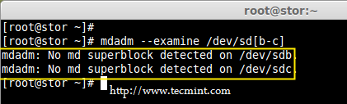

Check RAID Devices

In the above output, we come to know that none of the RAID have been applied to these two **sdb** and **sdc** drives.

### **Step 3: Creating Partitions for RAID**

**4.** Now create **sdb** and **sdc** partitions for raid, with the help of following fdisk command. Here, I will show how to create partition on **sdb** drive.

# fdisk /dev/sdb

Follow below instructions for creating partitions.

1. Press ‘**n**‘ for creating new partition.
2. Then choose ‘**P**‘ for Primary partition.
3. Next select the partition number as **1**.
4. Give the default value by just pressing two times **Enter** key.
5. Next press ‘**P**‘ to print the defined partition.

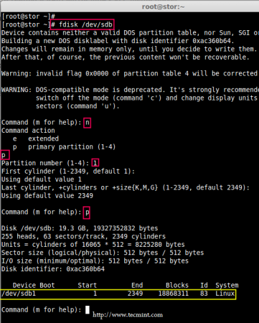

Create Partitions

Follow below instructions for creating Linux raid auto on partitions.

1. Press ‘**L**‘ to list all available types.
2. Type ‘**t**‘to choose the partitions.
3. Choose ‘**fd**‘ for Linux raid auto and press Enter to apply.
4. Then again use ‘**P**‘ to print the changes what we have made.
5. Use ‘**w**‘ to write the changes.

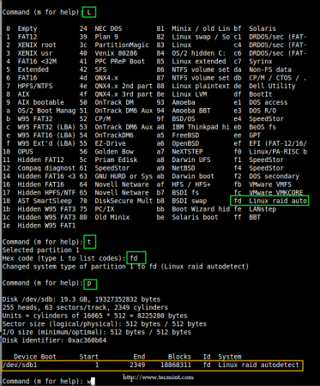

Create RAID Partitions in Linux

**Note**: Please follow same above instructions to create partition on **sdc** drive now.

**5.** After creating partitions, verify both the drivers are correctly defined for RAID using following command.

# mdadm --examine /dev/sd[b-c]

# mdadm --examine /dev/sd[b-c]1

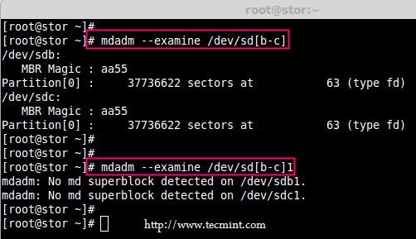

Verify RAID Partitions

### **Step 4: Creating RAID md Devices**

**6.** Now create md device (i.e. **/dev/md0**) and apply raid level using below command.

# mdadm -C /dev/md0 -l raid0 -n 2 /dev/sd[b-c]1

# mdadm --create /dev/md0 --level=stripe --raid-devices=2 /dev/sd[b-c]1

1. **-C** – create
2. **-l** – level
3. **-n** – No of raid-devices

**7.** Once md device has been created, now verify the status of **RAID Level**, **Devices** and **Array** used, with the help of following series of commands as shown.

# cat /proc/mdstat

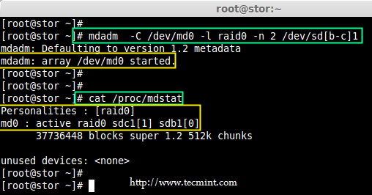

Verify RAID Level

# mdadm -E /dev/sd[b-c]1

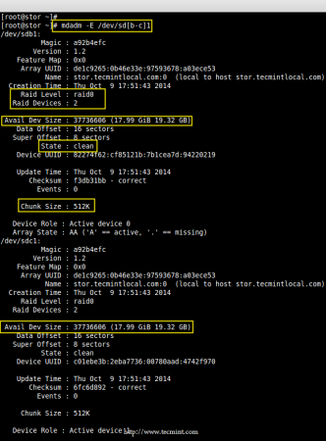

Verify RAID Device

# mdadm --detail /dev/md0

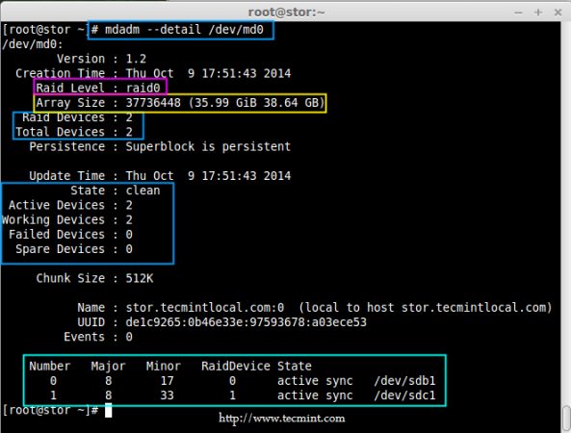

Verify RAID Array

### **Step 5: Assiging RAID Devices to Filesystem**

**8.** Create a ext4 filesystem for a RAID device **/dev/md0** and mount it under **/dev/raid0**.

# mkfs.ext4 /dev/md0

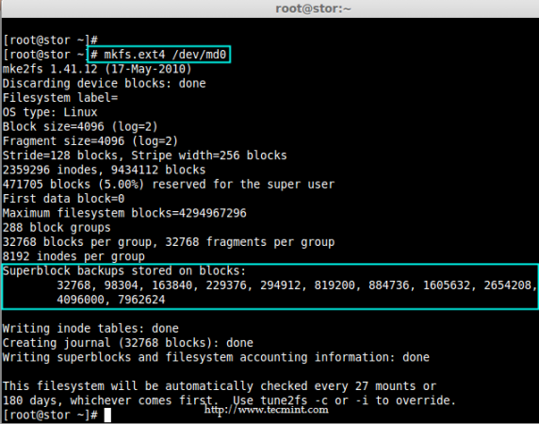

Create ext4 Filesystem

**9.** Once ext4 filesystem has been created for Raid device, now create a mount point directory (i.e. **/mnt/raid0**) and mount the device **/dev/md0** under it.

# mkdir /mnt/raid0

# mount /dev/md0 /mnt/raid0/

**10.** Next, verify that the device **/dev/md0** is mounted under **/mnt/raid0** directory using **df** command.

# df -h

**11.** Next, create a file called ‘**tecmint.txt**‘ under the mount point **/mnt/raid0**, add some content to the created file and view the content of a file and directory.

# touch /mnt/raid0/tecmint.txt

# echo "Hi everyone how you doing ?" > /mnt/raid0/tecmint.txt

# cat /mnt/raid0/tecmint.txt

# ls -l /mnt/raid0/

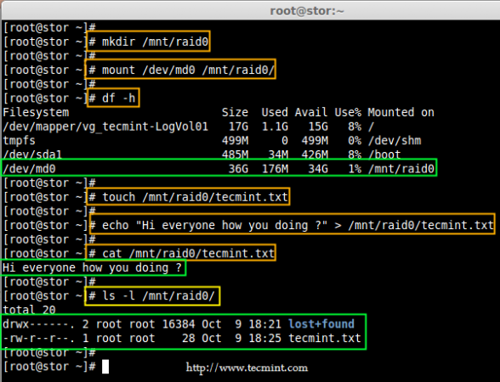

Verify Mount Device

**12.** Once you’ve verified mount points, it’s time to create an fstab entry in **/etc/fstab** file.

# vim /etc/fstab

Add the following entry as described. May vary according to your mount location and filesystem you using.

/dev/md0 /mnt/raid0 ext4 defaults 0 0

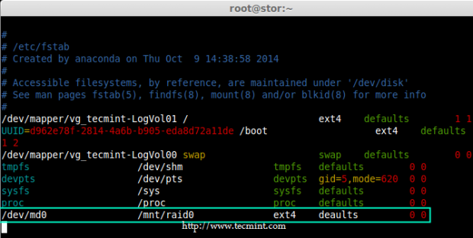

Add Device to Fstab

**13.** Run mount ‘**-a**‘ to check if there is any error in fstab entry.

# mount -av

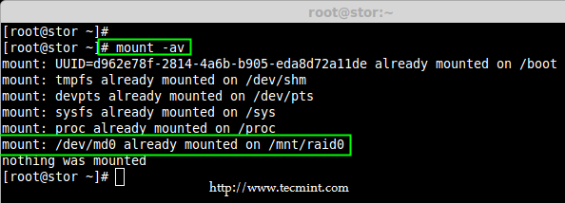

Check Errors in Fstab

### **Step 6: Saving RAID Configurations**

**14.** Finally, save the raid configuration to one of the file to keep the configurations for future use. Again we use ‘mdadm’ command with ‘**-s**‘ (scan) and ‘**-v**‘ (verbose) options as shown.

# mdadm -E -s -v >> /etc/mdadm.conf

# mdadm --detail --scan --verbose >> /etc/mdadm.conf

# cat /etc/mdadm.conf

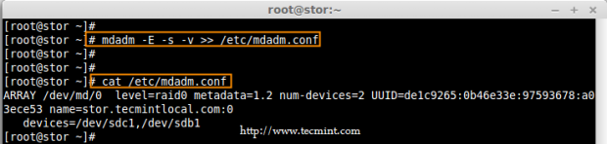

Save RAID Configurations

That’s it, we have seen here, how to configure RAID0 striping with raid levels by using two hard disks.